Grocery Store and Ecommerce Inventory Management Database: Final Report
CIS 411 Database Systems II
Dr. Qi
Group Number: (insert later)
An Individual Project by Lucas Bastos
05/4/26

1. Introduction
My project presents a database system for a grocery store with ecommerce, delivery, inventory, and supplier restocking features. I added the ecommerce aspect to create an extra layer of complexity and functionality to the otherwise typical grocery store database scenario. The database is designed to manage customers, online accounts, orders, order items, products, suppliers, payments, deliveries, inventory levels, and reorder requests. The goal of the system is to reduce manual record keeping and provide employees with accurate information about sales, order fulfillment, product stock, and restocking needs. The system supports core grocery store operations, including customer order processing, product sales tracking, payment tracking, delivery tracking, inventory monitoring, and supplier reorder management.
2. Core Assumptions / Business Rules
- A customer can place many orders.
- Each order belongs to at least one customer.
- One order can contain many order items.
- Each order item belongs to one order.
- Each order item references one product.
- A product can appear in many order items.
- Each product belongs to one category.
- Each category can contain many products.
- Each product is supplied by one supplier.
- Each supplier can supply many products.
- Each product has one inventory record.
- A product can have many reorder requests over time.
- Each reorder request is connected to one product and one supplier.
- Each order may have a payment record.
- Each order may have a delivery record.
- Each customer may have one online account (MAXIUMUM).
3. ER Diagram & Relational Diagram
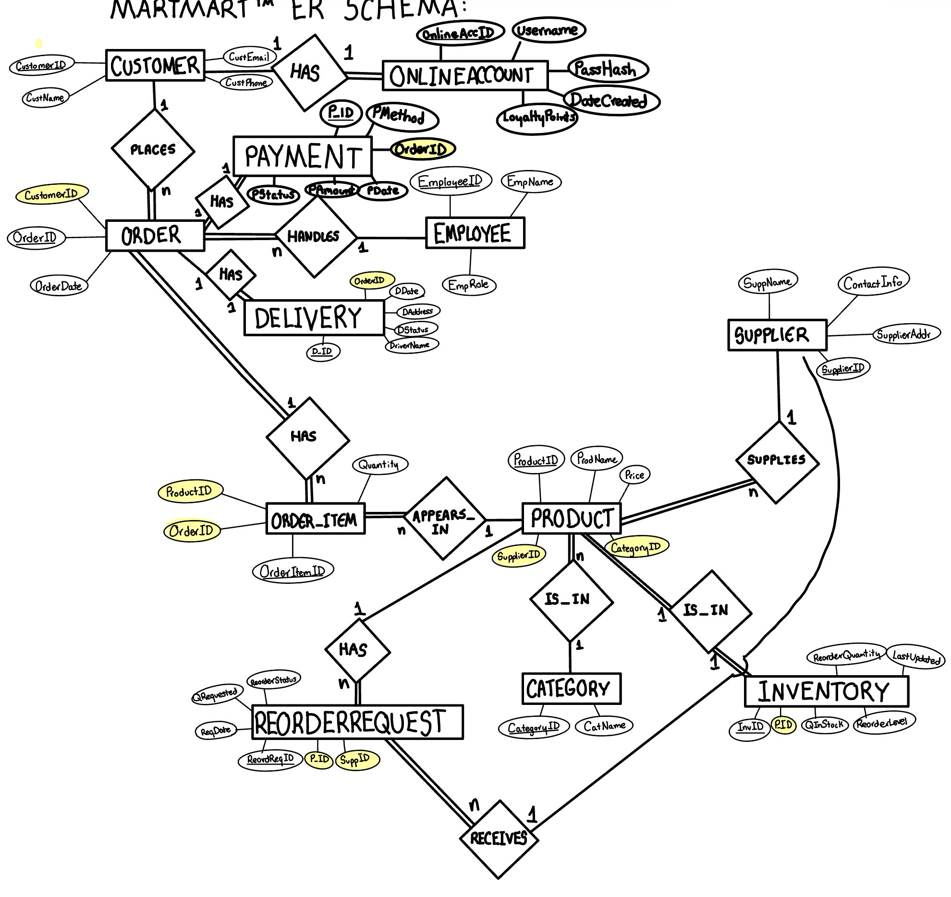
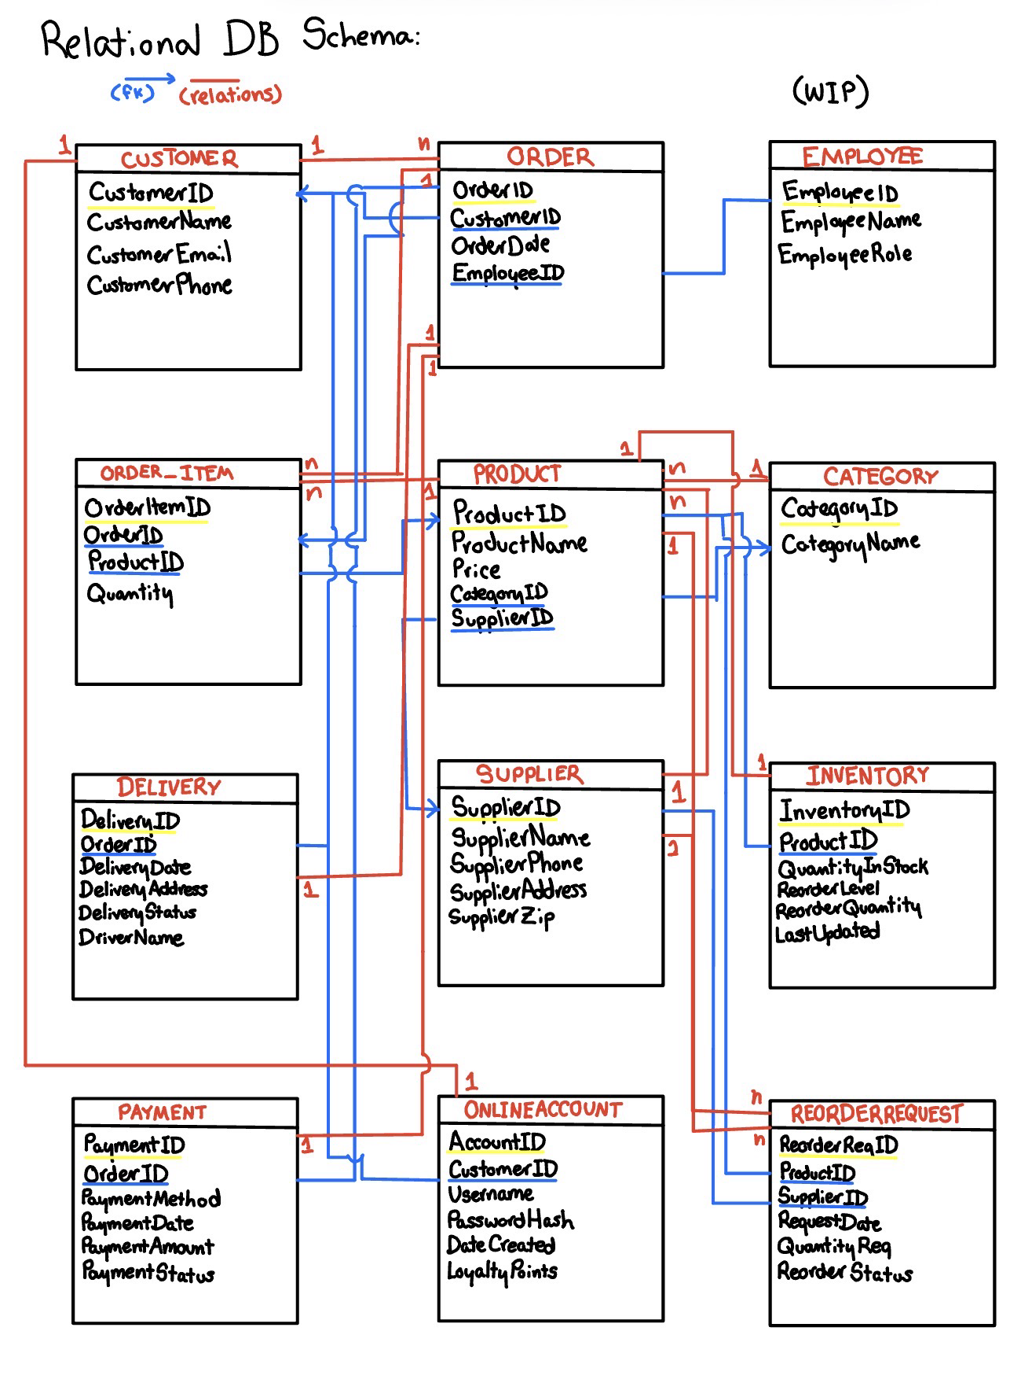
4. Normalized Relations
The database was normalized to reduce redundancy and improve data integrity. Each table represents a single entity, such as customers, products, orders, payments, deliveries, inventory, or reorder requests. Primary keys uniquely identify records in each table, while foreign keys connect related tables.
The overall design satisfies First Normal Form because each field contains atomic values and there are no repeating groups. For example, products in an order are not stored as repeated columns in the ORDERS table. Instead, they are stored in the ORDERITEMS table, which reduces redundancy.
It satisfies Second Normal Form as well, because non-key attributes depend on the entire primary key. Since most tables use a single-field primary key, partial dependency is avoided. The ORDERITEMS table separates order details from the order header and stores each product purchased as a separate record.
Finally, Third Normal Form is satisfied because non-key attributes do not depend on other non-key attributes. For example, category names are stores in the CATEGORIES table (its own entity) instead of being repeated ad nauseam in the PRODUCTS table, and supplier names are stored in the SUPPLIERS table instead of being repeated for every product.
One possible denormalization is storing CustomerAddress directly in the CUSTOMERS table and DriverName directly in the DELIVERY table. These choices were made to keep the project manageable. If the business needed to store multiple customer addresses or detailed employee driver information, separate CUSTOMERADDRESSES and EMPLOYEES relationships could be added in a future version.
6. SQL DDL
CUSTOMERS: Stores customer info.
Field | Data Type | Key | Description
CustomerID | AutoNumber/Number | PK | Unique customer identifier
CustomerName | Short Text |  | Customer’s full name
Email | Short Text |  | Customer email address
CustomerAddress | Short Text |  | Customer’s address

ONLINEACCOUNTS: Stores ecommerce account info.
Field | Data Type | Key | Description
AccountID | AutoNumber/Number | PK | Unique online account identifier
CustomerID | Number | FK | References CUSTOMERS.CustomerID
Username | Short Text |  | Customer’s online username
PasswordHash | Short Text |  | Stored password hash/sample placeholder
DateCreated | Date/Time |  | Date account was created
LoyaltyPoints | Number |  | Customer’s loyalty reward points

ORDERS: Stores customer order records.
Field | Data Type | Key | Description
OrderID | AutoNumber/Number | PK | Unique order identifier
CustomerID | Number | FK | References CUSTOMERS.CustomerID
OrderDate | Date/Time |  | Date the order was placed

ORDERITEMS: Stores the individual products inside each order.
Field | Data Type | Key | Description
OrderItemID | AutoNumber/Number | PK | Unique order item identifier
OrderID | Number | FK | References ORDERS.OrderID
ProductID | Number | FK | References PRODUCTS.ProductID
Quantity | Number |  | Quantity of product ordered

PRODUCTS: Stores grocery product information.
Field | Data Type | Key | Description
ProductID | AutoNumber/Number | PK | Unique product identifier
ProductName | Short Text |  | Name of grocery product
Price | Currency |  | Selling price
CategoryID | Number | FK | References CATEGORIES.CategoryID
SupplierID | Number | FK | References SUPPLIERS.SupplierID

CATEGORIES: Stores product category information.
Field | Data Type | Key | Description
CategoryID | AutoNumber/Number | PK | Unique category identifier
CategoryName | Short Text |  | Category name, such as Dairy, Produce, Snacks

SUPPLEIRS: Stores supplier info.
Field | Data Type | Key | Description
SupplierID | AutoNumber/Number | PK | Unique supplier identifier
SupplierName | Short Text |  | Name of product supplier

PAYMENT: Stores payment info for orders.
Field | Data Type | Key | Description
PaymentID | AutoNumber/Number | PK | Unique payment identifier
OrderID | Number | FK | References ORDERS.OrderID
PaymentMethod | Short Text |  | Credit card, debit card, PayPal, etc.
PaymentDate | Date/Time |  | Date payment was processed
PaymentAmount | Currency |  | Amount paid
PaymentStatus | Short Text |  | Completed, Pending, Failed, Processing

DELIVERY: Stores delivery tracking info.
Field | Data Type | Key | Description
DeliveryID | AutoNumber/Number | PK | Unique delivery identifier
OrderID | Number | FK | References ORDERS.OrderID
DeliveryAddress | Short Text |  | Address where order will be delivered
DeliveryDate | Date/Time |  | Date of delivery
DeliveryStatus | Short Text |  | Delivered, Processing, Delayed, In Transit
DriverName | Short Text |  | Driver assigned to delivery

INVENTORY: Tracks current stock level for each product.
Field | Data Type | Key | Description
InventoryID | AutoNumber/Number | PK | Unique inventory record identifier
ProductID | Number | FK | References PRODUCTS.ProductID
QuantityInStock | Number |  | Current stock quantity
ReorderLevel | Number |  | Minimum quantity before reorder is needed
ReorderQuantity | Number |  | Amount to reorder
LastUpdated | Date/Time |  | Last date inventory was updated

REORDERREQUESTS: Stores restocking requests for low-stock products.
Field | Data Type | Key | Description
ReorderRequestID | AutoNumber/Number | PK | Unique reorder request identifier
ProductID | Number | FK | References PRODUCTS.ProductID
SupplierID | Number | FK | References SUPPLIERS.SupplierID
RequestDate | Date/Time |  | Date reorder request was created
QuantityRequested | Number |  | Number of units requested
ReorderStatus | Short Text |  | Pending, Ordered, Received, Cancelled

7. Sample Data Explanation
Sample data was inserted into each table to demonstrate realistic grocery store operations. The database includes customers, online accounts, grocery products, suppliers, categories, customer orders, order items, payment records, delivery records, inventory records, and reorder requests. The amount of data utilized is large enough to demonstrate why a database is needed instead of a spreadsheet, with 30-50+ records for each relevant table.
8. Query Descriptions
Query 1: Customer Online Account List
Tables used:
CUSTOMERS, ONLINEACCOUNTS
Type:
2-table query
Purpose:
Shows customers and their ecommerce account information.
SELECT CUSTOMERS.CustomerName, ONLINEACCOUNTS.Username
FROM CUSTOMERS INNER JOIN ONLINEACCOUNTS ON CUSTOMERS.CustomerID = ONLINEACCOUNTS.CustomerID;

Query 2: Order Delivery Status
Tables used:
ORDERS, DELIVERY
Type:
2-table query
Purpose:
Shows each order and its delivery status.
SELECT ORDERS.OrderID, DELIVERY.DeliveryStatus
FROM ORDERS INNER JOIN DELIVERY ON ORDERS.OrderID = DELIVERY.OrderID;
Query 3: Order Payment Status
Tables used:
ORDERS, PAYMENT
Type:
2-table query
Purpose:
Shows payment method, payment amount, and payment status for each order.
SELECT ORDERS.OrderID, PAYMENT.PaymentStatus
FROM ORDERS INNER JOIN PAYMENT ON ORDERS.OrderID = PAYMENT.OrderID;
Query 4: Online Customer Activity
Tables used:
CUSTOMERS, ONLINEACCOUNTS, ORDERS
Type:
3-table query
Purpose:
Shows which online customers have placed orders and how many loyalty points they have.
SELECT CUSTOMERS.CustomerName, ONLINEACCOUNTS.Username, ONLINEACCOUNTS.LoyaltyPoints, ORDERS.OrderID, ORDERS.OrderDate
FROM (CUSTOMERS INNER JOIN ONLINEACCOUNTS ON CUSTOMERS.CustomerID = ONLINEACCOUNTS.CustomerID) INNER JOIN ORDERS ON CUSTOMERS.CustomerID = ORDERS.CustomerID;
Query 5: Product Sales Details
Tables used:
ORDERS, ORDERITEMS, PRODUCTS, EMPLOYEES
Type:
4-table query
Purpose:
Shows the products and quantities included in each order, along with the employee that processed them.
SELECT ORDERS.OrderID, PRODUCTS.ProductName, ORDERITEMS.Quantity, EMPLOYEES.EmployeeName
FROM ((EMPLOYEES INNER JOIN ORDERS ON EMPLOYEES.EmployeeID = ORDERS.EmployeeID) INNER JOIN ORDERITEMS ON ORDERS.[OrderID] = ORDERITEMS.[OrderID]) INNER JOIN PRODUCTS ON ORDERITEMS.[ProductID] = PRODUCTS.[ProductID];
Query 6: Pending Reorder Requests
Tables used:
PRODUCTS, SUPPLIERS, REORDERREQUESTS
Type:
3-table query
Purpose:
Shows products with pending reorder requests and the suppliers responsible for fulfilling them.
SELECT PRODUCTS.ProductName, SUPPLIERS.SupplierName, REORDERREQUESTS.ReorderRequestID, REORDERREQUESTS.RequestDate, REORDERREQUESTS.QuantityRequested, REORDERREQUESTS.ReorderStatus
FROM (PRODUCTS INNER JOIN REORDERREQUESTS ON PRODUCTS.ProductID = REORDERREQUESTS.ProductID) INNER JOIN SUPPLIERS ON REORDERREQUESTS.SupplierID = SUPPLIERS.SupplierID
WHERE REORDERREQUESTS.ReorderStatus = 'Pending';
Query 7: Low Stock Inventory Report Query
Tables used:
PRODUCTS, CATEGORIES, SUPPLIERS, INVENTORY
Type:
4-table query
Purpose:
Shows products that are at or below their reorder level, including category, supplier, current stock, and reorder quantity.
SELECT PRODUCTS.ProductID, PRODUCTS.ProductName, CATEGORIES.CategoryName, SUPPLIERS.SupplierName, INVENTORY.QuantityInStock, INVENTORY.ReorderLevel, INVENTORY.ReorderQuantity, INVENTORY.LastUpdated
FROM ((PRODUCTS INNER JOIN CATEGORIES ON PRODUCTS.CategoryID = CATEGORIES.CategoryID) INNER JOIN SUPPLIERS ON PRODUCTS.SupplierID = SUPPLIERS.SupplierID) INNER JOIN INVENTORY ON PRODUCTS.ProductID = INVENTORY.ProductID
WHERE INVENTORY.QuantityInStock <= INVENTORY.ReorderLevel;

Query 8: Pending Low Stock Reorder Report Query
Tables used:
PRODUCTS, CATEGORIES, SUPPLIERS, INVENTORY, REORDERREQUESTS
Type:
5-table query
Purpose:
Shows low-stock products that already have pending reorder requests. This query connects product information, category, supplier, inventory level, and reorder request status.
SELECT PRODUCTS.ProductID, PRODUCTS.ProductName, CATEGORIES.CategoryName, SUPPLIERS.SupplierName, INVENTORY.QuantityInStock, INVENTORY.ReorderLevel, INVENTORY.ReorderQuantity, REORDERREQUESTS.ReorderRequestID, REORDERREQUESTS.RequestDate, REORDERREQUESTS.QuantityRequested, REORDERREQUESTS.ReorderStatus
FROM (((PRODUCTS INNER JOIN CATEGORIES ON PRODUCTS.CategoryID = CATEGORIES.CategoryID) INNER JOIN SUPPLIERS ON PRODUCTS.SupplierID = SUPPLIERS.SupplierID) INNER JOIN INVENTORY ON PRODUCTS.ProductID = INVENTORY.ProductID) INNER JOIN REORDERREQUESTS ON PRODUCTS.ProductID = REORDERREQUESTS.ProductID
WHERE INVENTORY.QuantityInStock <= INVENTORY.ReorderLevel
AND REORDERREQUESTS.ReorderStatus = 'Pending';
9. Forms Descriptions
Form Name | Based On | Description
frmCustomers | CUSTOMERS | Allows users to enter and update customer information.
frmOnlineAccounts | ONLINEACCOUNTS | Allows users to manage ecommerce account records.
frmProducts | PRODUCTS | Allows users to manage grocery product records.
frmCategories | CATEGORIES | Allows users to manage product categories.
frmSuppliers | SUPPLIERS | Allows users to manage supplier information.
frmOrders | ORDERS | Allows users to enter and view customer orders.
frmOrderItems | ORDERITEMS | Allows users to enter products and quantities for each order.
frmPayment | PAYMENT | Allows users to record payment information.
frmDelivery | DELIVERY | Allows users to record delivery information.
frmInventory | INVENTORY | Allows users to update product stock levels.
frmReorderRequests | REORDERREQUESTS | Allows users to manage product restock requests.

10. Reports Explanation
1. Customer Purchase History Report
The Customer Purchase History Report displays each customer’s purchases by order. It shows order dates, products purchased, quantities, prices, and line totals. This report supports the sales side of the grocery store by allowing employees to review customer buying behavior and order history. It also helps solve the problem of understock and overstock, by tracking customer purchases more effectively, and predicting trends.
2. Pending Low Stock Reorder Report
Since the largest issue of this unspecified grocery store is its horrible inventory management skills, I have implemented not only a query to automatically generate a table of low stock inventory items, but also a final report containing all the streamlined information. This helps the employees determine which products need to be restocked.
11. Navigation Form
Tab | Items
Customers | frmCustomers, frmOnlineAccounts
Orders | frmOrderEntry, frmPayment, frmDelivery
Products | frmProducts, frmCategories, frmSuppliers
Inventory | frmInventoryManagement, frmReorderRequests
Reports | rptCustomerPurchaseHistory, rptPendingLowStockReorder

12. Conclusion
The Grocery Store and Ecommerce Inventory Management Database successfully organizes the major operations of a grocery store. The system stores the customer information, online account information, orders, order items, products, payments, deliveries, inventory records, and reorder requests of each product. The database supports sales tracking, ecommerce order management, delivery tracking, inventory monitoring, and supplier restocking. Through forms, queries, reports, and a navigation form, I feel confident that this database provides a usable application for managing grocery store operations.

